Sample Manuscript of Kobe Journal of Medical Sciences

(Style: TITLE)

ICHIRO KOBE1, MAIKO KYOTO1,*, NARUTO AWAJI1,  
MINO TAKARAZUKA2 and SUMIYOSHI OSAKA2 (Up to 3 authors in a line. Add “and” before the last author. Style: AUTHORS)

1Department of XXX, ABC University School of Medicine, Kobe, Japan;  
 2Team YYY, Osaka ZZZ Center, Osaka, Japan *Corresponding author (Style: Affiliation)

**Keywords:** Sample key words (Style: Article Body, Capitalize every first letter, Set “hanging indent” for 2nd and following lines to align line heads by the colon.)

(§Abstract… No need for subtitle. Style: Article Body, Font: Bold)

**Manuscripts should be typed with Microsoft Word (hereafter MS Word) in the following format and made into PDF document. Download a template, and type (or paste) texts. Use only “Times New Roman” fonts, except for “Symbol” fonts for Greek characters. In the first page, authors state title, names of authors, and the name and address of the laboratory where the work was performed. Also, list 4–6 key words, and input contacts of corresponding author, phone number, fax number (if applicable), and e-mail address in the footer section. Capitalize first letters of every title word and key words, except for articles and prepositions. Capitalize all letters of author names. Capitalize appropriate places of affiliations. In abstract section, authors summarize their argument, preferably within 250 words. Use bold letters. Avoid abbreviations and references. Do not include diagrams.**

(Style: Article Body)

Begin the argument with “Introduction.” After Introduction, make sections such as “Materials and Methods,” “Results (Clinical Case[s]),” “Discussion,” “Acknowledgements,” all with subtitles, as follows.

References should be listed in the “Reference” style at the end of the paper.

Input headers as follows: abbreviated title (up to 50 letters including spaces) for the paper’s header of the 3rd and subsequent odd pages, and first author’s name in every even-numbered page.

Finally, make the MS Word document into PDF file, with “Adobe Acrobat.”

(See http://adobe.com/products/main.html )

MATERIALS AND METHODS (Style: subtitle)

Materials (Style: Article Section)

The final typescripts will be posted as it is. We strongly encourage authors to finish proofreading before submission.

Methods

Minor points for proofreading are as follows. Use “Symbol” fonts for Greek characters, and “special characters” pallet from “Insert” Menu for plus minus and other mathematical characters.

Results

**What are “Styles”?**  --(Brief explanations for authors unfamiliar to the Style function) Styles enable you to apply styles to fonts and paragraphs without accessing the Ribbon or Menu-bar each time. For example, if you apply the style “Article Body” to a paragraph, the fonts are changed into “Times New Roman,” 10 pt, and the line-break intervals into 12 pt, and 1.5 em indent for the first line. We have named the described style “Article Body,” and added it to the template. In short, you can automatically change texts into Kobe Journal format by selecting “Styles.”   
**How to apply “Styles”** --Put the caret in the target paragraph, and select from “Style” box (usually next to the “font” box on the tool-bar).

**How to select?** --Click ▼ to view the lists, or, click once IN the Style box, and when the letters are highlighted, input the initial letter of Style name (for example “t” for TITLE), and choose by Arrow key (↓), and press Enter.

～Examples of embedding Figures & Tables ～

Figures and tables should be placed to appropriate places, instead of gathered at the end.

1. Legends at bottom.

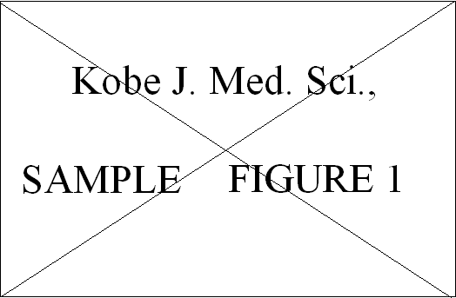

**Figure 1.** Figure legends should be placed under or right side of the figure.

(Style: Legends, Use bold for “Figure No.”)

2. Legends at right.

**Figure 2.**   
In this case, the legends look better to be placed at right side of the figure, because it leaves big blank if centered.

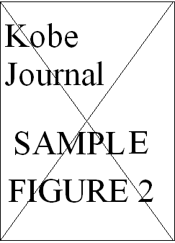

3.

|  |  |  |  |  |  |
| --- | --- | --- | --- | --- | --- |
|  | |  |  | | |
|  | KJMS  SAMPLE TABLE I |  |  |  |  |
|  |  |  |  |  |  |
|  |  |  |  |  |  |
|  |  |  |  |  |  |
|  |  |  |  |  |  |
|  |  |  |  |  |  |

KJMS: Kobe Journal of Medical Sciences

**Table I.** The table titles should be placed above the tables, and the legends should be placed below them.

discussion

Acknowledgements

REFERENCES

(Style: Reference)

1. Rose ME, Huerbin MB, Melick J, Marion DW, Palmer AM, Schiding JK, et al. Regulation of interstitial excitatory amino acid concentrations after cortical contusion injury. Brain Res. 2002;935(1-2):40–6.
2. Diabetes Prevention Program Research Group. Hypertension, insulin, and proinsulin in participants with impaired glucose tolerance. Hypertension. 2002;40(5):679–86.
3. eatright.org [Internet]. Chicago: Academy of Nutrition and Dietetics; c2016 [cited 2016 Dec 27]. Available from: https://www.eatright.org/.
4. …..